SANTA CALLING!
Help make your child’s Christmas season extra special this year with a personal telephone call from Santa Claus! The Peshtigo Park and Recreation have made arrangements with Santa at the North Pole to talk to your child this Christmas holiday. Calls will be placed on
Wednesday, December 17th, 2025, 5:30 – 7:30 pm.

If you live in Peshtigo or attend Peshtigo Schools and wish your child (3-9 years old) to receive a call from Santa, please complete a Santa Calling form and return by Tuesday, December 16th, 2025. Forms can be printed off from the City’s website at https://ci.peshtigo.wi.us/ or you can pick up a form at City Hall or the Peshtigo Library. Please feel free to make copies as well.

RETURN FORM TO:
SANTA CALLING
Peshtigo City Hall
331 French St.
Peshtigo, WI 54157

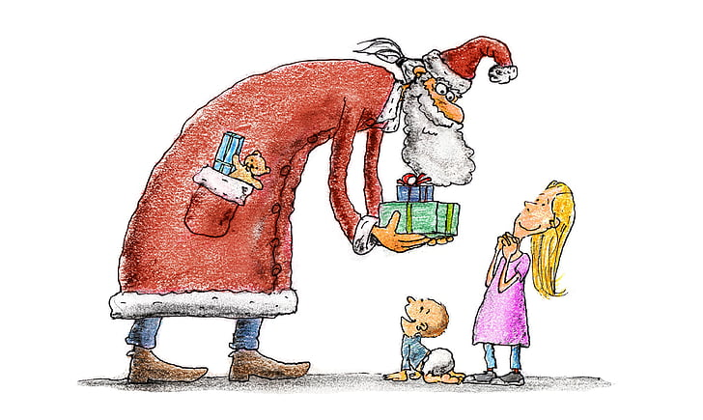
Christmas joy warms the heart!


Please print clearly & list correct phone number!!
Child’s Name: (first) ____________________ (middle) ______________________ (last) _______________________
Help Santa pronounce your child’s name correctly: ______________________________________________________
Girl: _______ Boy: _______ Age: _______ Telephone: __________________________________________________
Address: __________________________________ Parents’ names: ________________________________________
School: _______________________________ Grade: ________ Teacher’s name: _____________________________
Christmas Gift Requested: _________________________________________________________________________
Santa will not promise any special gifts to your child. He will only develop conversation and help discourage extraordinary expectations. Santa will try to encourage good behavior; list any you would like Santa to reinforce or compliment your child on. Examples: “get to bed on time”, “clean your room”, “care for pet”, “get along with sister or brother”, help clear the table”, etc.
Reinforce Compliment _____________________________________________ _____________________________________________ _____________________________________________ _____________________________________________ _____________________________________________ _____________________________________________ _____________________________________________ _____________________________________________
Is there a brother, sister, pet or special friend you would like Santa to mention? Please include ages of siblings/friends. ________________________________________________________________________________________________
________________________________________________________________________________________________
General Time Schedule for Calling: Wednesday, December 17th, 5:30 – 7:30 pm.
All children will be called who send in a form.

When is the BEST TIME for Santa to call? __________________________________ FAMILIES – Please send your forms in for each child STAPLED TOGETHER! Did you send in a form for another child? Yes ____ No _____ If yes, list the child (ren)’s name(s): ______________________________________

